**SE Revision**

*Ibrahim Abou Zahr – Mohammad Abdel Rahman – Yehya Fleifel – Ali Al Yaman*

**Task 1:**

**Instagram:**

Functional Requirements:

1. Posting: users can post any suitable photo they like on the app and it will show up on other user’s feed to view and like.
2. User search: users can hover over a search bar and search for any users or verified accounts and can view their page and follow them.
3. Messaging: users and message other user’s depending on the person’s privacy setting.

Non-Functional Requirements:

1. Performance: Posting photos on Instagram should take 5 seconds to process the request and to check if the Instagram post is suitable.
2. Security: two step verification is added to ensure that each account is well secure.
3. Legal requirements: all rights for 3rd party companies are reserved and can be shared on the app.

**Uber:**

Functional Requirements:

1. Taxi request: users can request for a nearby lift to arrive and pick them up at to take them to their desired destination.
2. Rate drivers: users can hover over a taxi’s profile and rate the experience with them using the stars rating system.
3. View map: users can press on the map icon to view their current location and to see if any nearby Uber drivers are located.

Non-Functional Requirements:

1. Performance: response time between a user and an Uber driver takes around 200ms.
2. Security: Uber drivers require to fill a form to verify if they are real drivers.
3. Usability: Interface is very user friendly especially for Uber drivers. Makes it clear and simple on how to contact a driver and when that driver has arrived to your destination.

**Task 2:**

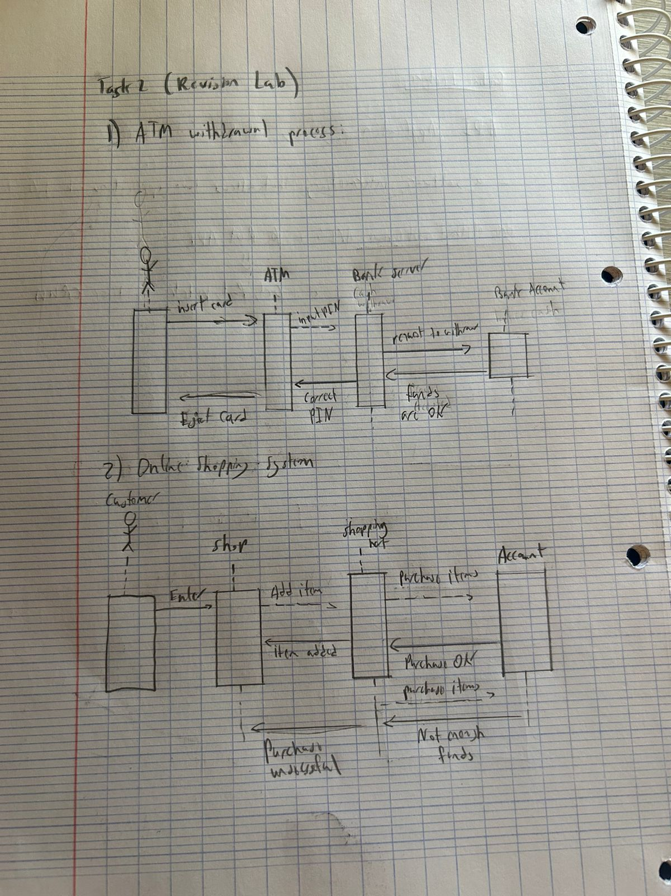

**Task 3:**

